Project Design Phase

Solution Architecture
Date | 18 June 2026
Team ID
Project Name | ShopEZ
Maximum Marks | 4 Marks

Solution Architecture:
Solution architecture is a complex process — with many sub-processes — that bridges the gap between business problems and technology solutions. Its goals are to:

- Find the best tech solution to solve existing business problems.
- Describe the structure, characteristics, behavior, and other aspects of the software to project stakeholders.
- Define features, development phases, and solution requirements.
- Provide specifications according to which the solution is defined, managed, and delivered.

ShopEZ — Solution Architecture Diagram:
The diagram below shows the high-level architecture of ShopEZ: a React (Vite + Tailwind) frontend communicating over a REST API with a Node.js/Express backend, which uses Mongoose to interact with MongoDB and Multer for image uploads stored on the server's file system.

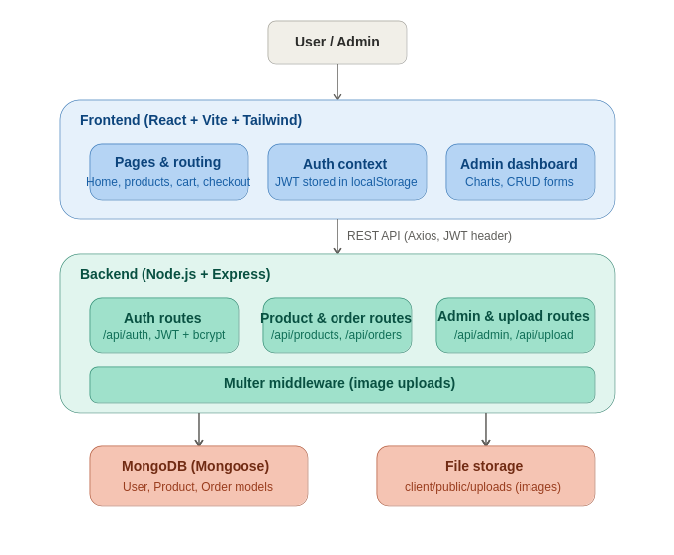
Figure 1: ShopEZ solution architecture

Architecture Components:
- Frontend (React + Vite + Tailwind CSS): Pages and routing for Home, Products, Cart, Checkout, Wishlist, and Auth; Auth Context storing JWT in localStorage; Admin Dashboard with analytics charts and CRUD forms.
- Backend (Node.js + Express): Auth routes (/api/auth) using JWT and bcrypt; Product & Order routes (/api/products, /api/orders); Admin & Upload routes (/api/admin, /api/upload); Multer middleware for handling product image uploads.
- Database (MongoDB + Mongoose): Stores User, Product, and Order models including roles, specifications, stock, pricing, and order status.
- File Storage: Uploaded product images are saved to the client/public/uploads folder and referenced by path in MongoDB.

